Area Code Overlay Approved for the Minnesota 507 Area Code

To make sure new telephone numbers are available, the Minnesota Public Utilities Commission approved the addition of the new 924 area code to the geographic region of the 507 area code. This process is known as an area code overlay.

What is an area code overlay?

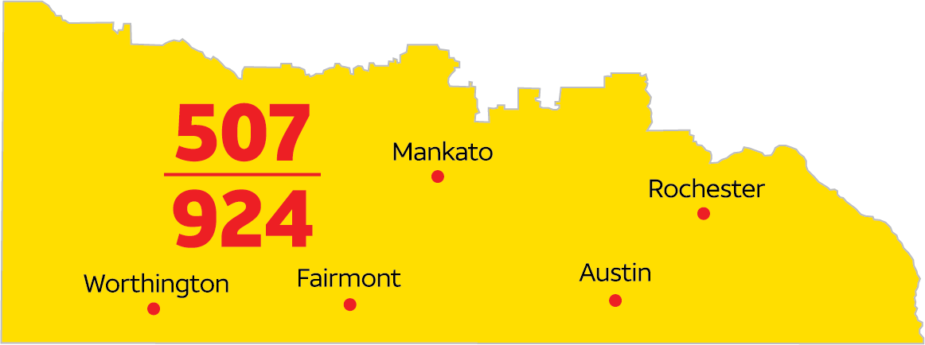
An overlay is the addition of another area code (924) to the same geographic region as an existing area code (507). An overlay does not require customers to change their existing area code but does require using a new dialing procedure to complete calls.

Who will be affected?
The 507 area code covers southern Minnesota and cities including, but not limited to Albert Lea, Austin, Fairmont, Mankato, Northfield, Rochester, Winona, Worthington, and other smaller communities. Anyone with a 507 area code will need to use a new dialing procedure, but will not have to change their telephone number. New telephone numbers may be assigned in the new 924 area code.

What will be the new dialing procedure?
All calls in the 507 area code geographic area that are currently dialed with seven digits will need to be dialed using area code + telephone number. The same dialing procedure will apply to both 507 telephone numbers and telephone numbers that are assigned in the new 924 area code.

When will the change begin?
Effective January 30, 2024, dial the area code + telephone number whenever you place a call. If you forget and dial just seven digits, your call will still be completed.

Beginning July 30, 2024, you must dial the area code + telephone number on all calls, including calls within your same area code. If you do not dial the area code + telephone number, your call will not be completed, and a recording will instruct you to hang up and dial again, including the area code.

Beginning August 30, 2024, new telephone lines or services may be assigned numbers with the new 924 area code.

What will change?
- Dial the area code + telephone number for local calls.
- All services, automatic dialing equipment, or other types of equipment that are programmed to dial a 7-digit number will need to be reprogrammed to include the area code. Some examples are: life safety systems and medical monitoring devices, fire or burglar alarm and security systems or gates, fax machines, Internet dial-up numbers, speed dialers, call forwarding settings, voicemail services and similar functions, etc.
- Update your websites, personal and business stationery and checks, advertising materials, personal and pet ID tags and other such items to ensure the area code is included.

What will remain the same?
- Your telephone number, including current area code.
- The price of a call, coverage area, or other rates and services will not change due to the overlay.
- What is a local call now will remain a local call regardless of the number of digits dialed.
- You can still dial just three digits to reach 911 and 988, as well as 211, 311, 411, 511, 611, 711 or 811 if available in your area.

Who may you contact with questions?
If you have any questions regarding information provided in this notice, please call the number showing on your bill or access the Minnesota Public Utilities Commission website at: https://mn.gov/puc/.

