Elimination of Area Code Boundaries between 480, 602 & 623
In the Phoenix Metro Area Effective September 12, 2023
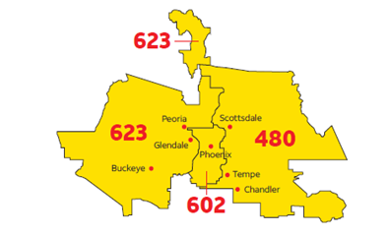
To ensure a continuing supply of telephone numbers in the Phoenix metropolitan area, the Arizona Corporation Commission has approved the elimination of the area code boundaries between the 480, 602 and 623 in the Phoenix metro area. This boundary elimination overlay does not require customers with a 480, 602 or 623 area codes to change their existing area code but does require them to include the area code and the seven-digit telephone number on every call, including calls within the same area code.

Who will be affected?
Everyone with a 480, 602 or 623 area code will be affected by this boundary elimination overlay. The 602 area code principally serves the City of Phoenix. The 480 area code primarily serves the eastern region including Scottsdale, Chandler and Tempe. The 623 area code is currently assigned to the western and northern most areas including Buckeye, Glendale and Peoria. Once the boundary elimination area code overlay is implemented, the entire Phoenix metro area will be combined and there will no longer be any geographic areas served separately.

When will the change begin?
Beginning August 12, 2023, 10-digit dialing will become mandatory throughout the 480, 602 and 623 area code regions, and calls that do not include the area code will not complete. If you forget and only dial 7 digits, you will hear a recorded message that advises you to include the area code. You will need to hang up and re-dial your call including the area code.

Beginning September 12, 2023, new telephone lines or services in the former ‘geographic’ areas served separately may now be assigned numbers from the area codes in 480, 602 or 623. All area code numbers may be ported throughout the Phoenix metro area since the boundaries between the area codes will be eliminated. As an example, if you or your business moves from Scottsdale to Phoenix, you will no longer be required to change your telephone number when moving into a different area code within the Phoenix metro area.

What will you need to do?
In addition to dialing 10-digits for all local calls, you should identify your telephone number as a 10-digit number (area code + 7-digit telephone number), and include the area code when giving the number to friends, family, business associates, and customers, etc. Please ensure all services, such as automatic dialing equipment, or other types of equipment that are programmed to dial a 7-digit number are updated to include the area code. Some examples are life safety systems and medical monitoring devices, PBXs, fax machines, Internet dial-up numbers, alarm and security systems, gates, speed dialers, mobile and cordless phone contact lists, call forwarding settings, voicemail services, and similar functions. Be sure to check your personal and business stationery, checks, advertising materials, websites, and your personal or pet ID tags to ensure the area code is included in your telephone number.

What will remain the same?
- Your telephone number, including the current area code, will not change.
- What is currently a local call will remain a local call regardless of the number of digits dialed.
- The price of a call or other rates and services will not change.
- You will continue to dial 1+ area code + telephone number for all long-distance calls.
- You can still dial just three digits to reach 911 and 988, as well as 211, 311, 411, 511, 611, 711, or 811, if currently available in your community.

Who may you contact with questions?
If you have any questions regarding information provided in this notice, please call 1-866-468-3472 or access the following websites for more information: https://allstream.com/support/us-customer-support/ or http://www.azcc.gov/utilities/telephone/all-about-area-codes.

